Table 1 shows the highest performing 5 schools, and table 2 shows the lowest performing schools in the district, ordered based on overall passing grades. When the two sets of data are compared, we observe that:

* The highest performing schools are all charter schools
* The highest performing schools have less students compared to the bottom five schools
* The total school budgets of highest performing schools are lower compared to the budgets of lowest performing schools.

**Table 1:**

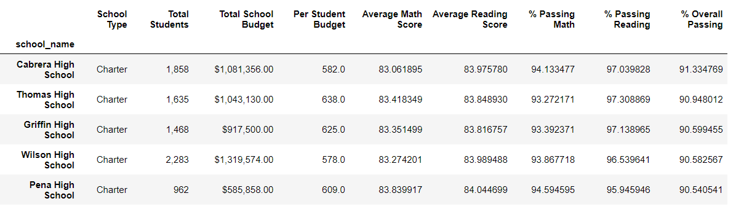

**Table 2:**

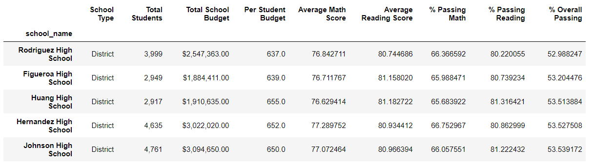

Table 2a & 2b summarize the math and reading scores by grade level, respectively for all the schools in the district. Overall, reading scores are higher compared to the math scores across schools and grade levels. The average scores across grade levels are consistent within each school.

**Table 2a: Table 2b:**

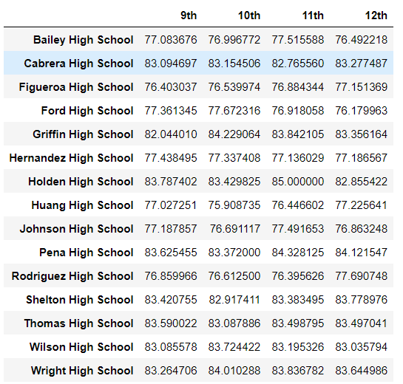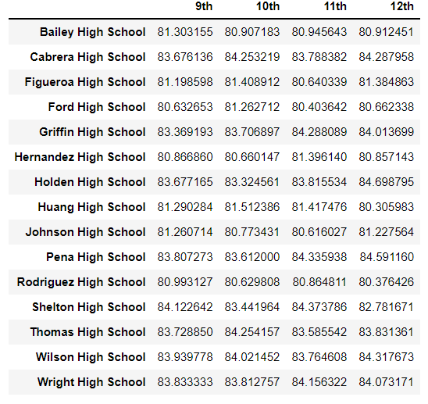

Table 3 summarizes average math, reading and overall passing grades by school spending. Graph 1, graphs the data found in Table 3 for better visualization. Based on these, we can see that schools with smaller budgets drastically outperform schools with bigger budgets, 90% vs. 53-62%, and spending is inversely proportional to math and reading scores.

**Table 3:**

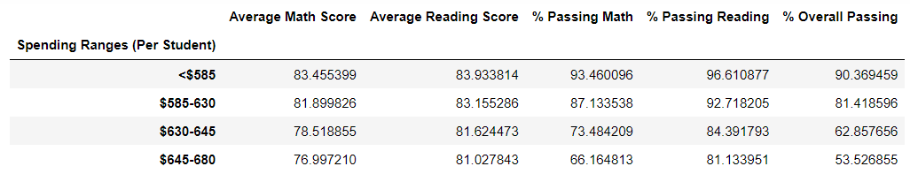

**Graph 1:**

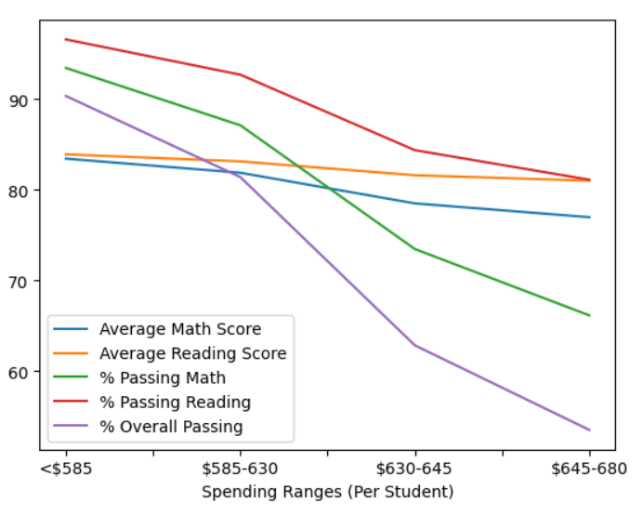

Table 4 shows that small and medium sized schools outperform the large sized schools, and Table 5 shows that charter schools performed better compared to district schools.

**Table 4:**

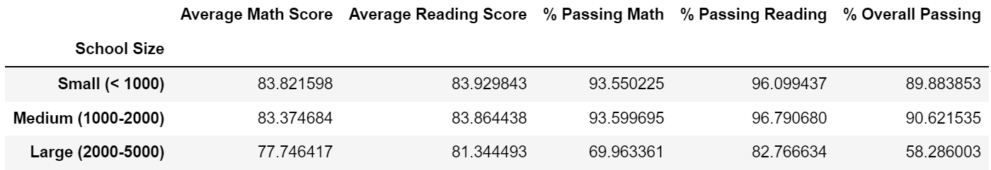

**Table 5:**

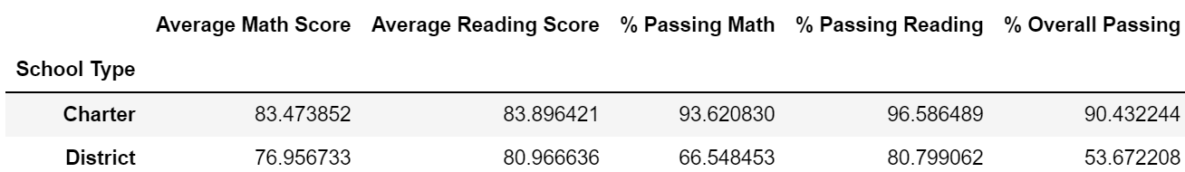

**Further considerations:**

Based on the given data, smaller schools, charter schools and those with smaller budgets per student seem to perform better. However, it is hard to determine causality solely on this analysis as charter schools seem to be smaller than district schools in general. Additionally, charter schools can receive additional funding through private channels that most district schools do not. Furthermore, the programs offered, staffing and the overall demographics may also contribute to the difference in performance and require further investigation.